In the Name of God

Internship Report

Writer:

Hussein Mohammadi

9766081

Supervised by:

Dr. Ashoori

Location:

Iranian Off-shore Oil Company

Lavan Island



Ahvaz - Iran

Summer 2022

Contents

Iranian Off-shore Oil company 1

Location 2

Lavan Oil Refinery 3

HSE Unit 5

Health 6

Safety 6

Environment 6

Classification of fuels: 7

air pressurized water extinguisher 10

Water (APW) Extinguishers 11

Carbon dioxide Extinguisher 12

Dry chemical Extinguishers 13

Rules for fighting fires 14

However, before deciding to fight the fire, keep these rules in mind: 14

Do Not Fight the Fire If: 15

Oil Fields 18

1. Salman Oil Field: 18

2. Resalat Oil Field: 19

3. Reshadat Oil Field: 20

4. Balal Oil Field: 20

Oil and Gas Laboratory 21

Density: 21

Procedure: 22

Measurement of water and solids 23

content 24

Shrinkage Factor: 26

Gas: 27

Production Unit 30

• Reservoir and Export Unit 30

Crude Oil Storage Tank 30

Branches: 34

Meter Bank 35

A summary about the system and how to load and adjust crude oil documents 38

• Lavan Oil Production Facility 39

Devices and Operational Variables for Oil Processing 41

Description of the process and operating variables: 42

Overall Description of the Unit 45

Multiple routes of the crude oil 48

Characteristics of crude oil entering the unit from oil fields: 49

# Iranian Off-shore Oil company

The Iranian Offshore Oil Company (IOOC) is a subsidiary of the National Iranian Oil Company. IOOC, an independent legal entity, is based in Tehran and operates in southern Iran. Its activities cover important areas of the Persian Gulf and its main operations are in Bushehr Province and on Kharg Island, Sirri Island and Lavan Island.

After Iranian Revolution, all partnership contracts with aforementioned companies were abolished, and a year later, the Iranian Offshore Oil Company (IOOC) was established by combining those companies. The objective underlying establishment of IOOC was to achieve an optimized production as well as to safeguard oil and gas reservoirs in the Persian Gulf area, along with an increase in the production rate and prevention of oil and gas migration in the common fields.During the Iraq-Iran War, the IOOC suffered considerable damages to offshore and onshore facilities.

The IOOC operations in the Persian Gulf are divided into two zones: the northern zone which includes oilfields around Kharg Island and ones near Iranian port of Bahregan. The Southern zone of the company's operations includes areas near islands Sirri, Lavan, Kish, Qeshm. The IOOC has the production capacity of over 640,000 b/d.

In 2012, IOOC signed a contract worth $6.6 billion, with Iran’s power projects management company (MAPNA) for developing the Forouz B gas field in the Persian Gulf and generating electricity from the produced natural gas.

In early 2015, IOOC acquired the "world’s largest oil tanker" with a capacity of 2.2 million barrels of crude oil. It is named "Persian Gulf". South Korea’s Samsung started building this floating storage unit (FSU) in 2008 and finished it at a cost of about $300 million.

# Location

Lavan Island is one of the islands of Hormozgan Province in the Persian Gulf. This island leads from the northeast to Bandar Maqam and from the east to Shidur (Camel) Island and is located 28 kilometers west of Nakhiloh beach in the waters of the Persian Gulf.

The length of this island is 23.5 and its maximum width is 4.8 kilometers and its area is 81 square kilometers and it is stretched from the west to the east. After the Qeshm Islands, Lavan Island is the largest Iranian island in the waters of the Persian Gulf.

On this island, there are about one hundred and fifty heads of jubeer, which is a kind of deer. There are also a large number of wild sheep scattered throughout the island, which have escaped from the domestic sheep of the island's residents to the lap of nature. From mid-March to early August, the island is a nesting place for several species of sea turtles, including hawksbill and green turtles.

The oil reserves of the waters near Lavan Island are very significant, currently the island's industries are limited to the oil facilities that operate under the name of "Lavan Refinery".

Iran's off-shore oil company has several oil extraction and exploitation platforms including Salman platform, Bilal platform, Resalat platform (known as R1) and Rashadat platform (known as R4) near the island, which can be reached by helicopter and ship.

Lavan Special Economic Zone Organization is responsible for the development of the facilities of Lavan Island. This organization operates under the National Iranian Oil Company. The axes of development of Lavan take place in three areas of energy economy, watershed management and fisheries. The new management of the Lavan Special Economic Zone organization plans to build Iran's first green village on the island of Lavan, focusing on sustainable development and compliance with environmental principles. Based on this, in this green village, despite the access to cheap and easily accessible oil and gas resources of the island, wind and solar renewable energy sources will be used, and in the construction of new buildings, the architecture compatible with the nature of tropical regions and based on the native architecture of Hormozgan will be used.

# Lavan Oil Refinery

Lavan Refinery or Lavan Oil Refining Company is one of the subsidiaries of Social Security Organization in Hormozgan province. This refinery has a nominal capacity of 50,000 barrels per day and an operational capacity of 55,000 barrels per day. The feed of this refinery is supplied from the crude oil of Salman, Reshadat, Bilal, Resalat and South Pars gas condensate fields.

Lavan Refinery was built in 1355 by the efforts of Ingra Company from former Yugoslavia and under the supervision of National Iranian Oil Company. This initial unit, named the Lavan Distillation Complex, began operations with a capacity to process 20,000 barrels of crude oil per day. In the early years, its products were:

* sour naphtha
* Gas oil
* Fuel oil

After the victory of the Islamic revolution and according to the strategic situation and the existing potential facilities, plans for the development and improvement of the system were put on the agenda. With the start of the war of imposition and damage to several refineries in the country, including the Abadan refinery, and as a result, the need for oil products increased. Gas and furnace oil, the importance of this unit was shown more than before. Until, during the years of holy defense, he performed the operation of refueling the naval fleet of the Islamic Republic of Iran in spite of numerous bombings in a worthy manner.

The Lavan refinery complex was formed at this time with the aim of producing better quality products. The Marax unit with a capacity of 6,000 barrels per day was designed by U.O.P company in 1368 and installed and started by Chyoda company in order to produce sweet naphtha. 2013 with the implementation of the crude oil distillation capacity increase plan, the mobile phone system with a crude oil production unit has increased production from 20,000 barrels to 30,000 barrels per day. and waste reduction was presented.

In 1380, with the help of domestic experts, the gasoline production unit of this refinery was launched, and in 1387, the dual-purpose petroleum-supply dock and the extraction and storage of liquid gas (LPG) of this company, which was burned in the flares of the refinery, were put into operation in 1387. Receipt.

On the 10th of May 2013, coinciding with the national day of the Persian Gulf, the first phase of the company's process improvement and capacity optimization plan, with the aim of increasing the capacity from 30,000 barrels per day to 55,000 barrels per day, was put into production.

Lavan Oil Refining Company, in order to improve the quality and increase the quantity of its production products and in the direction of protecting the environment, has implemented a plan to improve the process and optimize the capacity in the refinery. The honorable office of the presidency was put into operation in July 2013. In February 2014, the hydrogen purification unit for kerosene and gas oil distillation products was put into operation in accordance with the Euro 4 standard.

Currently, the feed of 35 thousand barrels (crude oil) of the refinery is supplied by a 12-inch pipeline from the facilities of Lavan Continental Plateau Oil Company and 20 thousand barrels of South Pars gas condensate (which is transported by ship to Lavan). The products of the refinery include gas oil and light naphtha, which is used domestically as super gasoline. Another production is fuel oil, which is exported. Among other products of Lavan Refinery, we can mention liquefied gas.

# HSE Unit

Petroleum industry makes use of many different activities in all the sectors of the business cycle: from upstream to downstream. Oil and services company’s management apply HSE policies to all levels of operations and in all sectors.

Health, Safety, Environment are separate issues, each with its own technology, but they are often combined in the same functional groups within the oil companies.

These three subjects are of paramount importance to the petroleum industry and adherence to HSE guidelines is a requirement for operators worldwide and is also dictated by internal policies of most corporations.

It is fundamental to have and implement an HSEMS (Health, Safety and Environmental Management System) which defines the principles by which operations are conducted and control the risks in the whole industry cycle.

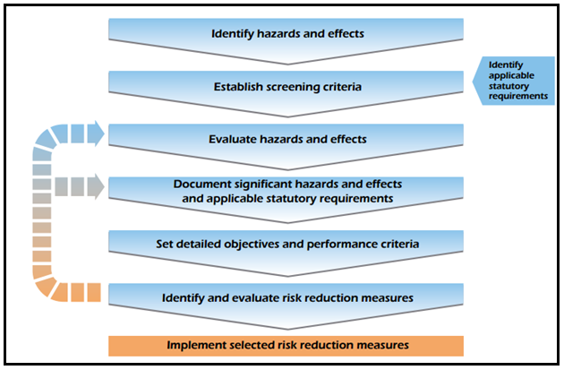

Figure 1: Risk Evaluation and Management Process

## Health

The health function typically deals with the well-being of the employees as they live and work in their environment.

It deals with the conduct of activities in such a way as to avoid harm to the health of employees and others, and to promote, as appropriate, their health.

Typically, the health function focuses on the effects of oil field chemicals and oil field physical environment on employees. Like wearing masks and appropriate uniform or gloves when dealing with toxic material.

## Safety

The safety function focuses on protecting the employee from risk involved during any type of operation and duties.

It is related to the principle that all injuries should be prevented and actively promote amongst all those associated with their activities the high standards of safety consciousness and discipline that this principle demands.

The safety function seeks to minimize these risks and monitor the effectiveness of the minimization activities.

## Environment

The environmental function focuses on the effects that petroleum activities have on the natural resources. The environmental issue pursuit the progressive reductions of emissions, effluents and discharges of waste materials that are known to have a negative impact on the environment, with the ultimate aim of eliminating them. It aims to provide products and services and advice which will not cause injury or undue effects on the environment.

It promotes protection of environments which may be affected by the development of petroleum activities and seek continuous improvement in efficiency of use of natural resources and energy.

All petroleum activities are subject to a declaration of environmental compatibility issued by the competent Authorities after in-depth studies of the possible environmental impact. These studies

* Identify sensitive environmental issues
* State possible environmental impact
* Provide a description of the technology and methodology necessary to reduce the risk of damage

The declaration of environmental compatibility is then issued on the basis of a synthetic evaluation which is the cornerstone for conclusions on how acceptable the environmental risk is in terms of chemical pollution, noise pollution, visual impact, smells and, more generally, of any other element which may interfere with the environment. Here we are going to give a very brief explanation of fires, fuels and fire extinguishers.

## Classification of fuels:

Not all fires are the same, and they are classified according to the type of fuel that  
is burning. If you use the wrong type of fire extinguisher on the wrong class of fire,  
you can, in fact, make matters worse. It is therefore very important to understand  
the four different fire classifications.

Class A - Wood, paper, cloth, trash, plastics  
Solid combustible materials that are not metals. (Class  
A fires generally leave an Ash.)

Class B - Flammable liquids: gasoline, oil, grease, acetone. Any non-metal in a liquid state, on fire. This classification also includes flammable gases. (Class B fires generally involve materials that Boil or Bubble.)

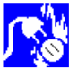Class C - Electrical: energized electrical equipment As long as it's "plugged in," it would be considered a class C fire. (Class C fires generally deal with electrical Current.)

Class D - Metals: potassium, sodium, aluminum, magnesium Unless you work in a laboratory or in an industry that uses these materials, it is unlikely you'll have to deal with a Class D fire. It takes special extinguishing agents (Metal-X, foam) to fight such a fire.

Most fire extinguishers will have a pictograph label telling you which classifications of fire the extinguisher is designed to fight. For example, a simple water extinguisher might have a label like the one below, indicating that it should only be used on Class A fires.



The Fire Triangle  
In order to understand how fire extinguishers work, you first need to know a little  
bit about fire.  
Four things must be present at the same time in order to produce  
fire:

1. Enough oxygen to sustain combustion,
2. Enough heat to raise the material to its ignition temperature,
3. Some sort of fuel or combustible material, and
4. The chemical, exothermic reaction that is fire.

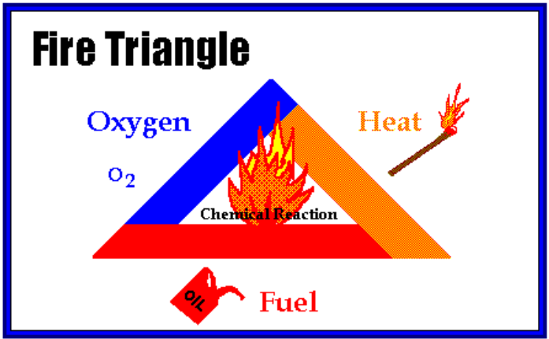

Oxygen, heat, and fuel are frequently referred to as the "fire triangle." Add in the fourth element, the chemical reaction, and you actually have a fire "tetrahedron." The important thing to remember is: take any of these four things away, and you will not have a fire or the fire will be extinguished.  
Essentially, fire extinguishers put out fire by taking away one or more elements of  
the fire triangle/tetrahedron.  
Fire safety, at its most basic, is based upon the principle of keeping fuel sources and  
ignition sources separate.

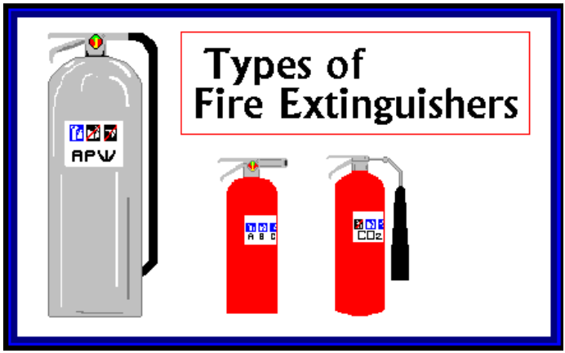

Different types of fire extinguishers are designed to fight different classes of fire. The three most common types of fire extinguishers are:

## air pressurized water extinguisher

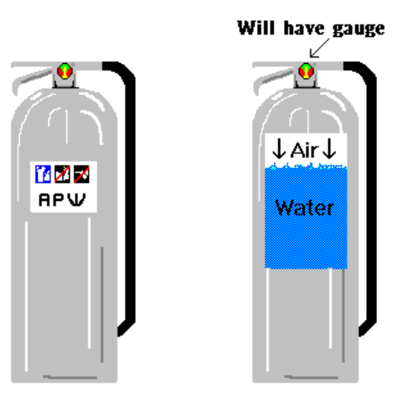

APW stands for "air-pressurized water." APWs are large, silver extinguishers that are filled about two-thirds of the way with ordinary tap water, then pressurized with normal air. In essence, an APW is just a giant squirt gun. APWs stand about 2 feet tall and weigh approximately 25 pounds when full.

Water (APW) Extinguishers

APWs are designed for Class A (wood, paper, cloth) fires only.



Never use water to extinguish flammable liquid fires. Water is extremely ineffective at extinguishing this type of fire, and you may, in fact, spread the fire if you try to use water on it. Never use water to extinguish an electrical fire. Water is a good conductor, and there is some concern for electrocution if you were to use water to extinguish an electrical fire. Electrical equipment must be unplugged and/or de-energized before using a water extinguisher on it. APWs extinguish fire by taking away the "heat" element of the fire triangle. APWs will be found in older buildings, particularly in public hallways, as well as in Residence Halls. They will also be found in computer laboratories. It is important to remember, however, that computer equipment must be disconnected from its electrical source before using a water extinguisher on it.

## Carbon dioxide Extinguisher

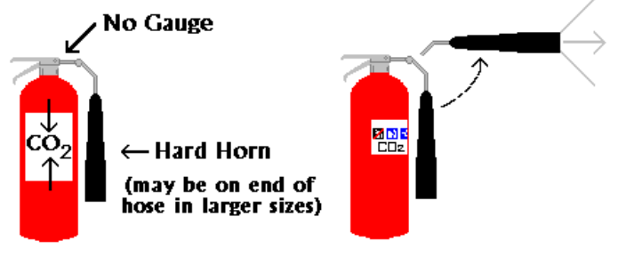

Carbon Dioxide extinguishers are filled with non-flammable carbon dioxide gas under extreme pressure. You can recognize a CO2 extinguisher by its hard horn and lack of pressure gauge. The pressure in the cylinder is so great that when you use one of these extinguishers, bits of dry ice may shoot out the horn. CO2 cylinders are red and range in size from 5 lbs to 100 lbs or larger. In the larger sizes, the hard horn will be located on the end of a long, flexible hose. CO2s are designed for Class B and C (flammable liquid and electrical) fires only. Carbon Dioxide is a non-flammable gas that extinguishes fire by displacing oxygen, or taking away the oxygen element of the fire triangle. The carbon dioxide is also very cold as it comes out of the extinguisher, so it cools the fuel as well. CO2s may be ineffective at extinguishing Class A fires because they may not be able to displace enough oxygen to successfully put the fire out. Class A materials may also smolder and re-ignite. CO2s will frequently be found in laboratories, mechanical rooms, kitchens, and flammable liquid storage areas.

## Dry chemical Extinguishers

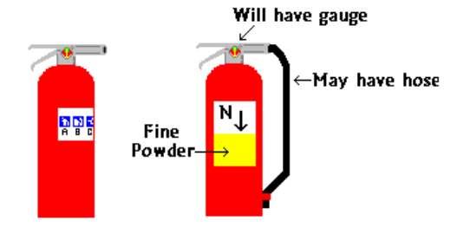

Dry Chemical Extinguishers come in a variety of types. You may see them labeled:

* "DC" short for "dry chem"
* "ABC" indicating that they are designed to extinguish class A, B, and C fires, or
* "BC" indicating that they are designed to extinguish class B and C fires.

"ABC" fire extinguishers are filled with a fine yellow powder. The greatest portion of this powder is composed of monoammonium phosphate. Nitrogen is used to pressurize the extinguishers.

It is extremely important to identify which types of dry chemical extinguishers are located in your area.

Read the labels and know their locations! You don't want to mistakenly use a "BC" extinguisher on a Class A fire, thinking that it was an "ABC" extinguisher.

An "ABC" extinguisher will have a label like this, indicating that it may be used on class A, B and C fires.

Dry chemical extinguishers put out fire by coating the fuel with a thin layer of dust, separating the fuel from the oxygen in the air. The powder also works to interrupt the chemical reaction of fire, so these extinguishers are extremely effective at putting out fire.

These extinguishers will be found in a variety of locations. New buildings will have them located  
in public hallways. They may also be found in laboratories, mechanical rooms, break rooms,  
chemical storage areas, offices, etc.

## Rules for fighting fires

Fires can be very dangerous and you should always be certain that you will not endanger yourself or others when attempting to put out a fire. For this reason, when a fire is discovered:

* Assist any person in immediate danger to safety, if it can be accomplished without risk to yourself.
* Activate the building fire alarm system or notify the fire department by dialing 911 (or designating someone else to notify them for you). When you activate the building fire alarm system, it will automatically notify the fire department and get help on the way. It will also sound the building alarms to notify other occupants, and it will shut down the air handling units to prevent the spread of smoke throughout the building.
* Only after having done these two things, if the fire is small, you may attempt to use an extinguisher to put it out.

## However, before deciding to fight the fire, keep these rules in mind:

Know what is burning. If you don't know what is burning, you don't know what type of extinguisher to use. Even if you have an ABC extinguisher, there may be something in the fire that is going to explode or produce highly toxic smoke. Chances are, you will know what's burning, or at least have a pretty good idea, but if you don't, let the fire department handle it.

The fire is spreading rapidly beyond the spot where it started. The time to use an extinguisher is in the incipient, or beginning, stages of a fire. If the fire is already spreading quickly, it is best to simply evacuate the building, closing doors and windows behind you as you leave.

## Do Not Fight the Fire If:

You don't have adequate or appropriate equipment. If you don't have the correct type or large enough extinguisher, it is best not to try to fight the fire.

You might inhale toxic smoke. If the fire is producing large amounts of smoke that you would have to breathe in order to fight it, it is best not to try. Any sort of combustion will produce some amount of carbon monoxide, but when synthetic materials such as the nylon in carpeting or foam padding in a sofa burn, they can produce highly toxic gases such as hydrogen cyanide, acrolein, and ammonia in addition to carbon monoxide. These gases can be fatal in very small amounts.  
Your instincts tell you not to. If you are uncomfortable with the situation for any reason, just let the fire department do their job.

The final rule is to always position yourself with an exit or means of escape at your back before you attempt to use an extinguisher to put out a fire. In case the extinguisher malfunctions, or something unexpected happens, you need to be able to get out quickly, and you don't want to become trapped. Just remember, always keep an exit at your back.



It's easy to remember how to use a fire extinguisher if you can remember the acronym PASS, which stands for Pull, Aim, Squeeze, and Sweep.

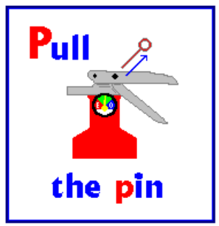**Pull the pin.**  
This will allow you to discharge the extinguisher.

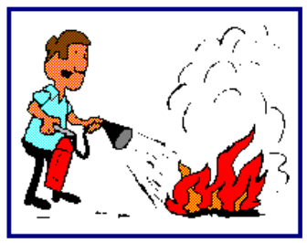**Aim at the base of the fire.**  
If you aim at the flames (which is frequently the temptation), the extinguishing agent will  
fly right through and do no good. You want to hit the fuel.

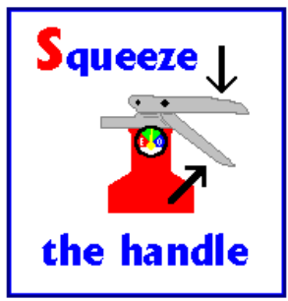**Squeeze the top handle or lever.**  
This depresses a button that releases the pressurized extinguishing agent in the extinguisher.

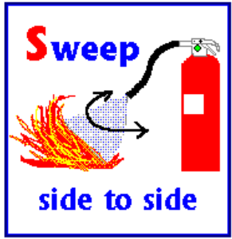**Sweep from side to side**until the fire is completely out. Start using the  
extinguisher from a safe distance away, then move forward. Once the fire is out, keep an eye on the area in case it re-ignites.

# Oil Fields

1. Salman Oil Field: This field is located 144 kilometers south of Lawan Island and is shared with Abol Bukhosh field (Abu Dhabi). Salman field has 42 oil wells and 10 injection wells. Its daily production after primary and secondary purification is about 60 thousand barrels of crude oil. The produced oil is sent to the land facilities of Lavan Island for processing and storage through a 22-inch marine pipeline.

The Salman field is located in the center of the waters of the Persian Gulf, and its area is 11*14 km. This field is located between Iran and Abu Dhabi, two-thirds of which is located in Iranian waters is called Salman, and one-third of it is located in Abu Dhabi waters. It is called Abul Bukhush. The maximum area that can be produced from it is 6000 acres. The distance between Salman Square and Lawan Island is about 140 km.

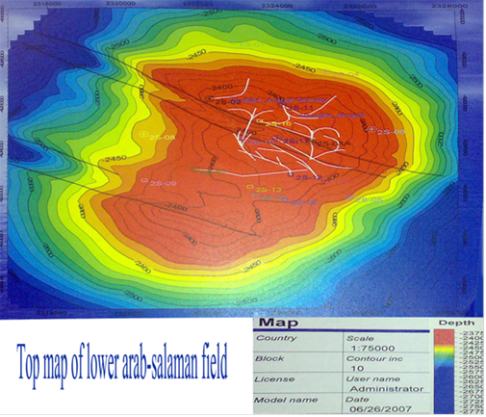

Salman field consists of two upper and lower formations. The upper formation is called Arab and the lower formation is called Buwaib and Shuaiba. The age of the upper formation is Jurassic and Tama and the age of the lower formation is Cretaceous. The Arab Formation is located between two Darb and Hith formations, the lower part of this formation is 90 feet of limestone rocks, and the upper part of the formation is mainly dolomite rocks, and the Buwiab formation is marine carbonate and mainly dolomite.

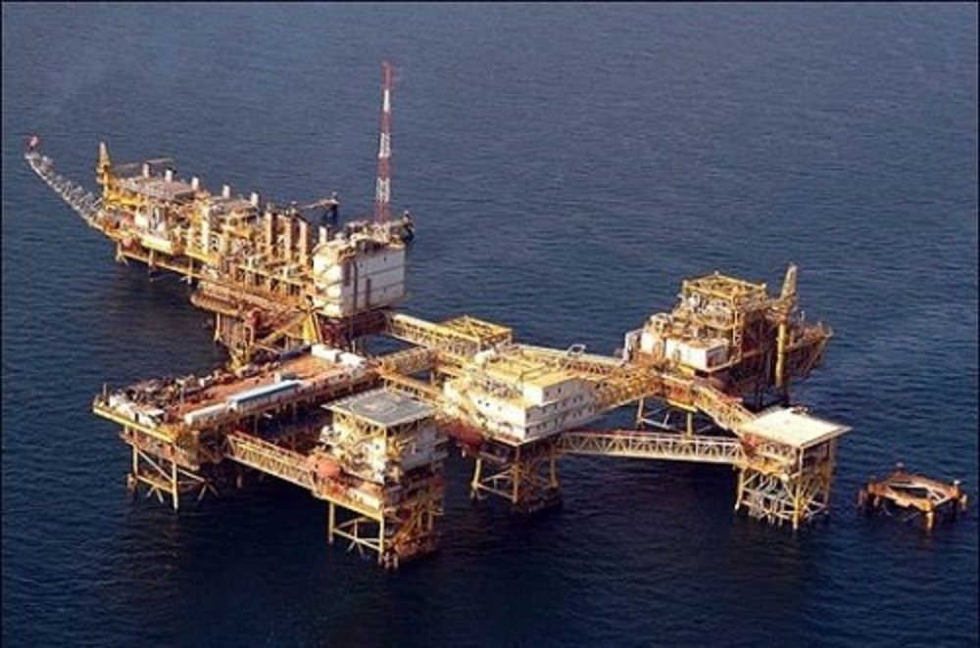

Figure 2: salman platform

1. Resalat Oil Field: This field is located 93 km southwest of Lawan Island and has 14 wells and the daily production of this semi-active field is about 8 thousand barrels.

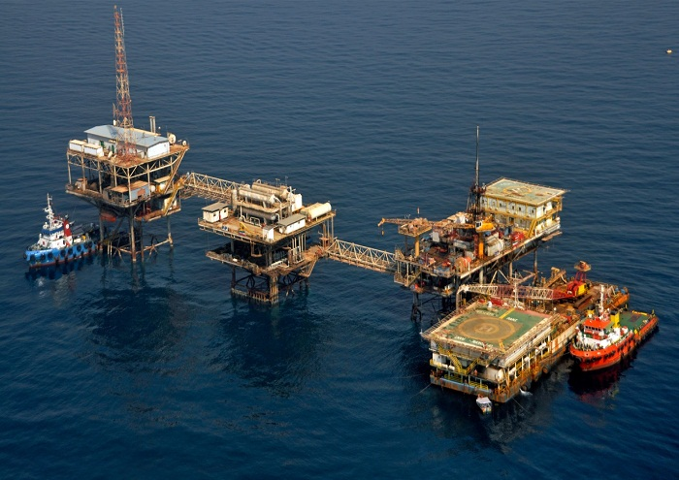

Figure 3: Resalat Platform

1. Reshadat Oil Field: This field is located about 110 kilometers southwest of Lavan Island and has two sets of platforms named Reshadat 3 and Reshadat 4. Platform No. 3 was attacked by the Americans and has been completely destroyed, so that no production takes place from it.

Reshadat 4 platform has 14 wells with a daily production of 4,000 barrels and its oil is transferred to Lavan by a 14-inch pipeline along with the oil from Resalat field.

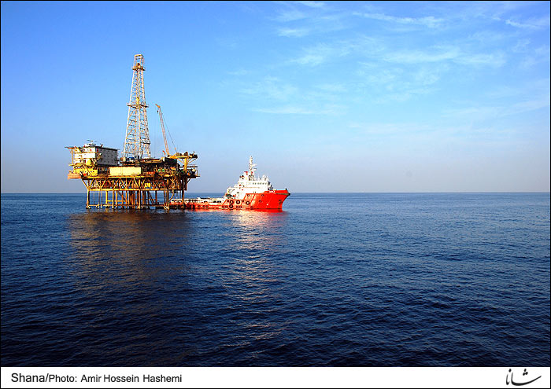

Figure 4: Reshadat Platform

1. Balal Oil Field: This field is located 93 kilometers southwest of Lawan Island, and its oil with a production rate of 15,000 barrels per day is sent to Lawan for storage through a 14-inch offshore pipeline.

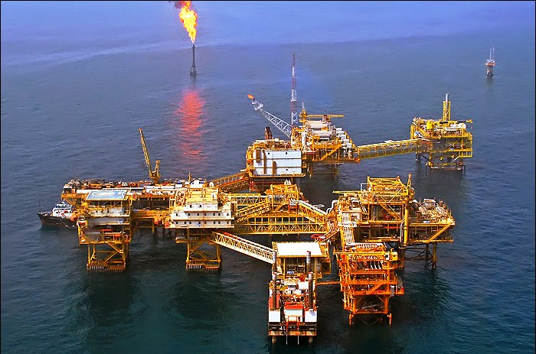

Figure 5: Balal platform

Figure 6: Balal Platform

# Oil and Gas Laboratory

As we know, in the industry, especially the oil industry, it is very important to know the favorable or unfavorable performance of the devices that are in service. It is very important to know whether the performance of the device in question is consistent with the designed goals or not and to what extent its performance is close to the designed limit. For example, how much hydrogen sulphide is the output gas from the sweetening unit? How much does the salt remover reduce the amount of salt in the oil? What is the composition of water in boilers? That the quality of the final product depends completely on the performance of the devices.

Therefore, a unit called the laboratory has been established next to the oil facilities, which will clarify the answers to the above and many other issues. In fact, the laboratory shows us the performance report of the devices, which can be used to get the desired results from the devices or to find out their faults.

In this unit, oil, gas, and water samples are tested daily and according to ASTM, IP, and method standards. The tests performed on oil, water and gas samples are as follows:

Tests are done on oil to determine the API grade, the percentage of water in the oil, the amount of hydrogen sulfide in the crude oil, and the viscosity of the crude oil (if necessary) from the incoming oil to Lavan (oil sent from the platforms).

Tests are done on the gas to determine the percentage of hydrogen sulphide gas entering the sweetening unit and exiting the sweetening unit to determine the performance of the sweetening device. Tests are done on drinking water to determine the amount of sulfite, iron, dissolved solids, suspended solids and water hardness. We remind you that in this laboratory, samples are also taken from oil storage tanks. We’ve discussed some of the tests that are carried out on oil and gas down below here. Specific density. Gr (use of pycnometer) 1- Pycnometer 2- Accurate scale with an accuracy of 0.0001/g 3- Ice water bath 4- Acetone

## Density:

The pycnometer which is full of distilled water is refilled and to prevent the water from heating and expanding, we freeze the pycnometer in a water bath and place it in a 25°C water bath. If the level of distilled water in the bathroom goes down, we put it back. The water level goes down due to contraction, we weigh the pycnometer in the same way and call the resulting weight A. Then we evacuate the pycnometer, dry it and fill it with the sample and place it in a bath of 25 degrees Celsius. Since the surface of the sample remains constant in the pycnometer, we place it in a Waston ice water bath. After 1 to 2 minutes, we weigh and call the resulting weight B. If we call the volume of the pycnometer V, the density of the sample is calculated as follows:

Since most pycnometers are set at 25°C and the device measures the volume at 25°C, it is necessary to weigh the pycnometer at 25°C. It is obvious that if the pycnometer is set at a different temperature, it is necessary to test the pycnometer at the same temperature of the tested sample. SPECIFIC GRAVITY Items needed: 1- Density meter 2- Thermometer 3- Cylinder 500 4- Ice water bath

## Procedure:

We take the sample in a container whose lid can completely seal and absorb. We put it in the ice water bath and mix it completely. Then pour the sample in the 500 cylinder and immerse the thermometer and the density meter in it and place the cylinder in the water bath. When the thermometer shows 60 degrees Fahrenheit and remains at this level, the thermometer We take it out and read the density of the sample immediately from the density meter.

Since oil is one of the liquids that stick to the wall of the container, we add 0.0005 units to what we read as a visual error in each test.

In this experiment, the specific gravity of the sample is measured but because it was measured in conventional conditions and the air pressure on the seashore is one atmosphere, the specific gravity, specific mass, and density are equal. It is obvious that the density of liquids at high altitudes should be measured using a pycnometer. If during the density test, foam is produced on the sample, it is necessary to add a drop of gasoline on the surface of the sample, and then continue the test.

## Measurement of water and solids

Equipment:

1. Centrifuge device
2. Special conical test tube
3. Hot water bath
4. Required solution:
5. Solvent toluene
6. Demulsifier separators

**Procedure:**

Mix the contents of the sample thoroughly to obtain a uniform mixture. Then we select 50cc of the sample and pour it into the test tube. After adding 3 drops of demulsifier, we fill another 50 cc of the test tube with toluene solvent. After mixing the contents of the tube completely, we put it in a 60°C hot water bath. For 10 minutes and after the heat exchange, we take out the test tube, dry it and put it in the centrifuge. We turn on the device and choose a speed that does not break the test tubes.

After 10 minutes of rotation inside the device, the water and solids in the crude oil, under the influence of centrifugal force, are deposited at the bottom of the test tube, turn off the device and pour one hundred volumes of water and solids in the oil from the degrees We read the test tube. Since we have increased the 50-cc sample to 500-cc, we multiply the B.S & W value read by a factor of 2.

Then we empty the oil and we report the heavy black oil material that accumulates above the water level, as the volumetric percentage of the reaction in the oil, observing the coefficient of 2

## content

Equipment:

1. One-liter balloon
2. Salt gas bottle
3. Rubber tube
4. Erlen Meyer 250cc
5. Plastic valve
6. Separating funnel with a lid

Necessary solutions:

1. solution 50 grams per liter
2. Sodium thiosulfate solution 0.1 normal
3. concentrated acetic acid CH3COOH
4. Gluten solution
5. Iodine solution 0.1 normal

Set up the assembly like the following:

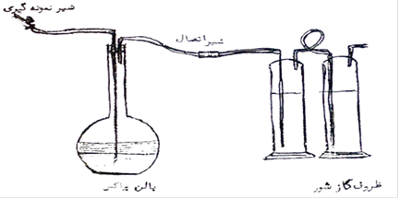



We pour 200 cc of Brax solution inside the balloon and 200 cc inside each of the salt gas jars. Then we close the lid of the balloon and weigh it together with the connecting tubes (A). Connect the balloon to the saline gas bottles through the connecting valve and make sure that the gas does not come out of any of the connections. If the concentration of hydrogen sulfide is less than 200 ppm, from one glass of saline gas, up to 500 ppm from 2 glasses of saline gas, and up to 1000 ppm from 3 glasses of saline gas, the hydrogen sulfide absorption of gases released from We use balloons. Take the mounted device to the sampling location and after removing the old oil from the connecting pipes and replacing it with new oil, connect the valve of the device to the valve of the sampling location and open the valve of the device completely.

Then open the sampling valve little by little so that the oil enters the balloon from under the Brax solution and the emitted gases are transferred to the salt gas bottles through the connecting pipes. After taking about 200 cc of sample, we first close the valve of the sampling source, separate them from each other and move the balloon vertically until all the gases in the oil are separated from it and transferred to the saline gas bottles. After no more bubbles are seen in the saline gas glasses, we separate the balloon from the connecting valve and weigh it again together with the connecting pipes and call the resulting weight B.

Therefore, the weight of the sample taken is equal to B-A. Remove the lid of the balloon along with the connecting tubes and after adding a few drops of separating material, close the lid. and pour the contents of the balloon into the separating funnel to separate the oil from the Brax solution.

And we have chosen only 50 cc of it, we consider a factor of 4 for the volume of consumed iodine. Now we subtract the volume of Brax solution from the volume of consumed iodine and call the obtained volume v1. Because the volume of Brax inside the balloon is 200 cc, we neutralize the saline gas bottles with iodine solution in the same order and obtain the volume of consumed iodine in this step. Now the ppm of hydrogen sulfide is obtained from the following equation:

The formula of the test reactions is as follows:

This sampling method is for sources where the pressure easily drives the oil into the balloon. If the sampling source has no pressure or if we want to take samples from different depths of the tank, the test is done in another way, which we will describe below. After sampling, we close the lid of the sample container and put it in an ice water bath. Then we pour 50 cc of Brax solution with a few drops of separating material into the separating funnel and add 150 cc of the sample inside the separating funnel to the Brax solution.

Close the lid and mix the contents of the funnel well, and while mixing, turn the funnel upside down and open the valve to exchange pressure. The hydrogen sulphide of oil is absorbed by Brax solution. Then put the funnel on the base so that the oil from Brax's solution will settle. Now, we select 25 cc of Brax's solution and neutralize it in an Erlenmeyer with 0.1 normal iodine solution. (the iodometric method of the previous test), if we multiply the consumed iodine by a factor of 26.6, PPM of hydrogen sulfide oil is obtained.

## Shrinkage Factor:



First, we empty the air from the special capsule by a vacuum pump and weigh it. Then fill the capsule with distilled water and weigh it. This weight difference is the weight of distilled water, which is divided by the specific weight of distilled water and we get its volume.

Now fill the capsule with oil, so that we weigh the gas in it and subtract the initial weight of the empty capsule from it to get the weight of the oil. Then we divide the weight of oil by its specific weight and get the volume of crude oil. The calculations are as follows.

## Gas:

Equipment:

1. Rubber tube
2. Gas burette
3. Base and Metal clamp
4. Storage container for Gluten solution

Required solutions:

1. Iodine solution with a normality of 0.04034
2. Gluten solution

We fill the storage container with Gluten and pour the iodine solution inside the special burette and connect the two containers to each other by means of a rubber tube. Open valve number 1 and 2 and adjust valve number 3 in a position so that the lower chamber of the buret is connected to the sampling location. Due to the surface difference between the Gluten solution container and the buret chamber, it is filled with Gluten solution.

Now, from the sampling location, we enter the tested gas into the chamber, so that the gas pressure drives the Gluten solution and the chamber is filled with gas up to the 100-cc mark, we remove the valve number 3 from the base and the 100-cc mark is near the solution surface. We put the Gluten in the storage container, open the valve number 3 so that the excess gases are released and the level of the Gluten solution in the chamber remains constant at the 100-cc mark. Close valve number 3. In fact, we have collected 100-cc of gas in the port.

Now keep the burette up so that the Gluten solution in the burette will be lower with the difference in level. We close the valve number 1 and 2 and separate the rubber tube from the burette. This action is for the pressure drop inside the buret chamber to pull the iodine solution inside. We put the valve number 3 in a position so that the iodine solution enters the gas chamber little by little. In this case, the iodine solution is neutralized by the existing hydrogen sulfide gas and the blue color of the iodine disappears in the Gluten solution. For every drop of iodine that we add, we close valve number 3 and stir the solution completely, and we repeat this process until the color of iodine remains in the Gluten solution. This means that all the hydrogen sulfide gas is neutralized by iodine and the excess iodine turns the color of the Gluten solution blue and indicates the end of the experiment.

To calculate hydrogen sulfide, we multiply the consumed volume of iodine by a factor of 300 and calculate the concentration of gas in the mixture of gases in terms of green units per 100 cubic feet.

1. Because the lid of the iodine burette is closed, after adding a few drops of iodine, the pressure inside the iodine burette decreases and prevents the flow of iodine. Therefore, it is necessary to open and close the burette door every time after adding iodine to exchange pressure.
2. If the concentration of hydrogen sulphide gas in the gas mixture is less than 300 grams per cubic foot, it is necessary to dilute the iodine solution three times and convert its factor to 100. For this, it is enough to add 100 cc of iodine solution. Make up to 300 cc with distilled water.

The report table of crude oil and gas tests of Lavan laboratory is as follows:

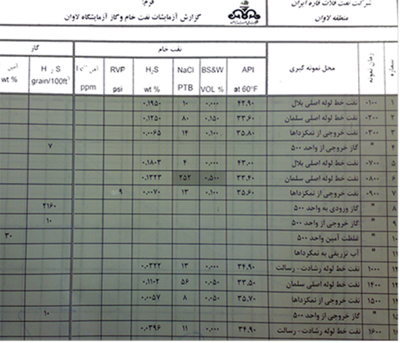

Figure 7: Table of crude oil and gas tests of Lavan laboratory

# Production Unit

## Reservoir and Export Unit

Iranian Continental Shelf Oil Company was established in early September 1359 with the aim of extracting and exploiting crude oil and natural gas in the Persian Gulf. This company includes four regions: Khark, Behrgan, Lawan, and Siri, and an office in Kish Island. Lawan region includes Salman, Bilal, Rasalt and Rashad oil fields.

The oil sent from the mentioned platforms to carry out a series of processing steps in the platforms, in Lavan Island, the separation steps of H2S gas, water and salt are also carried out in order to obtain high-quality oil up to the global standards and according to the customer's request. In general, storage, preparation, loading and export of crude oil is the responsibility of the storage, loading and export of crude oil.

The parts of the tanks, the area of ​​the branches, the area of ​​the loading meters, the area of ​​the loading control room, the area of ​​the SBM pumps can be mentioned as important parts of this unit, and we will describe each of them.

### Crude Oil Storage Tank

Crude oil is stored in 8 tanks located in the Lavan facility. Tanks numbers 1, 2, 2, 4, 5, 6 have a capacity of half a million barrels and tanks 7 and 8 have a nominal capacity of one million barrels.

All the crude oil tanks are cylindrical in shape and for entering and leaving crude oil, a 42-inch pipe is used for each tank, except tanks 6 and 7, which are used jointly.

The tanks are located in two rows, the level of tanks 3 and 4 is 7 feet more than tanks 1 and 2, and the level of tank 6 is also 7 feet more than tanks 3 and 4, and the level of tanks 7 and 8 is also 7 feet more than the level of tank 6, so that the level Tanks 7 and 8 are 21 feet more than tanks 1 and 2. Storage tanks consist of different parts, which are briefly described:

1. Roof

The roof of all tanks is floating and the roof goes up and down as the oil level rises and falls.

The roof of the half million-barrel tanks is double-walled in the middle and around, and the rest of the parts are single-walled. There are two valves on the roof of these tanks, which are closed and open only during tank repairs. Under these valves, there are stairs through which you can go from the bottom of the tank to the roof and vice versa. Also, there are 3 points for measuring oil or silage or sampling.

A pipe 4 is installed on the roof of these tanks to drain the liquid collected on the roof. that this pipe is connected to the main drain pipe of the tank and it is called Roof Drain, under the roof, metal bars are installed for the roof to sit on the floor, which is called Land, which is possible to prevent such a thing from happening Prevention is done so that the roof and floor are not damaged, so it always keeps the roof in a floating state. The roof of these tanks is at a height of 5.3 from the floor of the land tank. However, the roof of the one-million-barrel tanks is fully double-walled, with three emergency valves, eight gas vents and four roof drains. The roof drain of this tank goes around the tanks and the roof of these tanks is at a height of 6 feet from the tank floor.

1. Rubber Seal

It is a rubber or sponge ring that covers all around the roof of the tanks. The ring is used to prevent oil and gas leakage on the roof and prevent it from hitting the tank wall, as well as reducing the friction between the roof and the body.

1. Weather Shield

The metal plates that cover all around the roof and over the RUBBER SEAL and prevent foreign objects from hitting the rubber ring and rainwater.

1. Oil level measuring rod, temperature sampling:

This rod is 8 inches in half million-barrel tanks and 10 inches in one-million-barrel tanks and it is fixedly installed from the top of the tank with the bottom of the tank. The height of this pipe is called GAUGE HEIGHT, which is the same height as the height used to measure the tank. Measuring the oil level through the mentioned pipe and using a meter that is measured in feet and inches and is done in two ways: INNAGE and ULLAGE, which are briefly explained:

1. ULLAGE:

This method, which is relatively simpler, is that the meter is sent into the rod so that some of it enters the oil, then by placing the meter next to the edge of the rod, subtract the entered amount from the height of the rod with the same GAUGE HEIGHT of the tank. and then we add the result with the amount of oil from the meter, which represents the amount of oil inside the tank.

1. INNAGE:

That method is to send the meter to the end of the tank and the amount of oil in the meter is the amount of oil inside the tank. To calculate this height, the table corresponding to each tank is used, which is in (American) barrels.

1. Temperature

It is a device used to measure the temperature of crude oil. This process is done by sending a thermometer connected to a string into the measuring tube, which takes a few minutes and is taken inside with the middle of the amount of oil. The thermometer is in degrees Fahrenheit.

1. Sampling

This action is also used through measuring glasses in which a basket is used in which the glass is placed. By placing the glass in the basket and closing its lid with a cork, it is sent into the tube to the desired size through the string, and by pulling the string, the lid suddenly opens and the glass is filled with oil, then the glass is pulled up. And it is transferred to the laboratory by placing it in a container containing ice. Sampling is usually done from three points and the purpose of sampling is to determine the amount of water, salt, H2S and gravity and Api of the oil.

1. Water Drain

With the pipeline for draining the water settled in the tanks, this pipe is taken in the middle of the bottom of the tank and is used to drain the water separated from the oil. This pipe is 4 inches in half million barrel tanks and 6 inches in one million barrel tanks. The tank's water drain pipe is connected to an 8-inch underground pipe that is poured into the skimmer.

1. Skimmer

It is a relatively large pond that is used to collect oil or water and oil drained from tanks and facilities. In addition to the big pond, there is also a small pond that is connected through two gutters. By two chutes, oil collects on the water of the larger pond and enters the smaller pond. Then it is sent to the facility by a pump installed on a small pond. This pump has a float that turns on the pump and drains it when the oil level rises in the reservoir. Naturally, the pump turns off when the oil level drops.

1. Main Hole

Valves around the tanks that only open for entry and exit during repairs.

1. Auto Gauging

It is a radar system that is installed on the measuring pipe and by sending information through the cable to the control room and the existing system, it shows the amount of oil level, temperature and pressure, etc.

1. Mixers

If the crude oil in the tank is stagnant for a while, it causes accumulation and formation of silt at the bottom of the tank, and to prevent this, stirrers are installed and by circulating the liquid, it prevents the formation of silt. Agitators have the ability to change direction and their number is three in half million-barrel tanks and four in one-million-barrel tanks.

1. 42 inches entering and exiting pipes

These pipes are considered as the inlet pipe at the time of receiving liquid into the tank and as the outlet pipe of the tank at the time of liquid discharge. Except for tanks 6 and 7, which share this pipeline with the branch area, the rest of the tanks have a separate line each. The 42-inch pipe has branches. Next to tanks 6 and 7, an electric valve has been installed on each of the 42-inch pipes, and when oil enters and leaves the tank, only the same tank is returned. There is a 42 valve on the way to the entrance and exit of the other tanks. There is a manual gate valve. In addition, there is a safety valve before each valve that transfers excess pressure to the discharge pipeline.

1. Reservoir safety equipment

In order to secure the tanks from various accidents, there are devices around the entrance of the tank, each of which has an effect to prevent fire. Among them:

1. Fire pipes that are installed around the tanks and these pipes are through the salt water pump. Firefighting is provided.
2. Circular pipes that are stretched above the tank and around it, and these pipes contain foam. These pipes open automatically in case of fire and prevent air from reaching the flame and prevent the progress of the fire.
3. Manual fire extinguishers placed on the top of the tank, which are used in case of emergency.
4. The embankment around the tanks, which is for the purpose of preventing one of the tanks from overflowing, or for some reason oil spills into the other. Tanks do not spread.

### Branches:

1. crude receiving line

The processed crude oil enters the branches through a 20-inch pipeline to be sent to the desired tank. In this line, there are 6 16-inch solenoid valves, each of which is used separately to open and close a tank.

1. Pipe line whose oil is being sent to refinery complex

This pipeline is 10 inches long and has six 8-inch manual valves that are connected to the inlet and outlet pipelines of the tanks.

1. Transfer Line

This 10-inch pipeline has six 8-inch manual valves, from which oil can be transferred from one tank to another in two ways.

1. Through the level difference: with this method, the oil of the upper-level tank is transferred to the lower-level tank, and with this, both valves of the desired tank should be opened.
2. Through transfer pumps: when we want to transfer oil from a lower level to a higher level, we put transfer pumps into service. A 4-inch pipeline is connected to this pipeline, where the contaminated oil sent from the complex can be stored in the desired tank.
3. Transfer Pumps

Two transfer pumps named B1300 and A1300 have been installed in the basin of the branch area and they can be used in various operations. Opening the 20-inch hand valve of the tank to be transferred to the pump inlet (suction operation is prepared) before turning on the pump, first ventilate it and the inlet of the tank to be transferred is also opened, then after turning on the pump, the hand valve of the pump outlet that connects We open the output of the pump and the transfer pipeline until the output pressure of the pump is normal 60 psi and the sound of the pump is normal 0. Another use of the pump is for Crude Charge Pump when there is a lack of steam. The pump is used.

1. Sump Pumps

This pump is used to drain water or the water resulting from a 2-inch drain towards the skimmer. It should be noted that because this point is lower than the skimmer, the water in the 42-inch pipeline is collected at this point and drained through a 2-inch pipe and poured into a small pond, and then transferred to the skimmer through this pump. to be

### Meter Bank

This unit is used to measure the amount of oil sent to the ship in terms of barrels and consists of two separate and similar parts.

1. Internal numbering

It is connected to the internal pipelines, which are taken from the 36-inch pipeline in the branches for two meters and have the same equipment. At the beginning of each branch, a 16-inch hand valve (normally open), then a strainer, a vector number gauge (M.C.V), and then an electric valve (M.C.V), also a flow control valve (F.C.V) and an automatic sampler are also on the output header is SKID installed.

1. External numbering

This section consists of four 16-inch branches with the same specifications as above and is connected to the outer loading line.

In the following, we will explain the things that exist in each branch.

1. Strainer

This container is used to catch the waste material with the oil so that it does not get damaged when it enters the meter. Two branches are taken from the inlet and outlet of the strainer, which are connected to a pressure gauge. The difference in pressure is more than 5 psig, which indicates a clogging of the strainer. .

Under the strainer, a 3-inch valve (for liquid discharge) is connected to a four-inch pipe, while a half-inch safety valve and a gas discharge valve are installed on each strainer.

1. Meter

It is a device that shows the sent oil in terms of barrels. A flow transmitter is installed on each gauge, which sends the amount of oil passing to the control room, as well as the temperature and pressure values sent by the senders. will be

1. Auto Sampler

This sampler has a capacity of 8.4 gallons of oil. The sampler has the ability to adjust the direction of the oil in proportion to the passing oil, so that for each pulse, 1.5 cc of crude oil is taken from waste and stored in each tank.

In general, meters are mechanical tools and have an error factor, so they do not show the actual amount of oil passing through. In this sense, each meter must be tested and tested through a system of stabilizers to obtain a factor to eliminate the error. which plays a role in testing factors such as the pressure and temperature of the meter and the pressure and temperature of the stabilizer ring.

The test operation, which is called POROV, can be performed both on-site and from inside the control room. In the Provo route, which is the sub-loading route, a solenoid valve is connected to the common 24-inch header, which then leads to a four-way valve for oil movement in four directions. A 30-inch U-shaped pipe for moving oil back and forth, then two DETECTOR switches are installed on the pipe. The volume of the pipe between the two switches is 18 barrels, which is commanded to the switches with a ball inside the pipe, each round trip of the ball is called a TRIP.

Now, after performing the Provo operation, it is necessary to close and return the main oil path of a meter. When the oil enters the header, according to the direction of the four-way valve, it is directed to a U-shaped tube and moves the ball, which pulses when it hits the first switch and stops when it hits the second switch. The movement of the ball moves approximately 18 barrels. These pulses are recorded on the spot or in the computer. Every 1000 pulses is one barrel. After the oil passes through this route, it enters the main oil delivery route from the other side of the four-way valve and goes to loading. A 24-inch solenoid valve is installed in the oil outlet for each skid.

The process of proving and stabilizing continues until the value received by the system from each successive TRIP is close to an acceptable value. If the Provo action is performed by the system, their value is fixed in the printout and can be checked, otherwise, we put the numbers we have obtained locally in the following formula and get the meter coefficient:



### A summary about the system and how to load and adjust crude oil documents

Before starting the download, a series of operations must be performed as follows:

1. The water in the desired tank must be drained in several stages before loading.
2. We drain the water from the lowest point of the pipeline (in the area of ​​the branches) of the loading tanks.
3. We measure the size and temperature of the crude oil in the tanks.
4. We close the drain valves of the substrainers and meters for a few seconds to drain the possible water from the next arm.
5. We drain the water from the loading pipelines in the vicinity of the meters and the lowest point of the dock.
6. We empty the existing sampler from the previous oil and are ready to use it.
7. We write down the numbers of all the meters and record them in the relevant forms.
8. We open the desired loading tank on the loading lines.
9. We close the 16-inch valves of each skid and open them by half an inch.

Before starting the loading in the control room, a series of user measurements are performed on the system:

On the loading system, information about: 1) the name of the loading vessel 2) the requested amount of crude oil 3) the name of the captain 4) the name of the monitoring representative 5) the loading operator 6) the determination of the amount of automatic sampling, etc. Then enter START BATCH, the system is empty of previous information and new information is replaced and ready to load. Docking and tying ships to the wharf or SBM is the responsibility of the people of Lavan oil port.

In order to monitor and carry out the affairs correctly, a representative of the buyer and a representative of the oil exporter are present, who check and supervise the measurement of the dry tanks and the closing of the 16-inch sub-valves. After closing the ship and making the necessary arrangements, loading is done with full precision. At the start of loading, according to the amount of crude oil, the valves of the meters are open. This passing value of temperature and pressure of each meter and their sum and average can be seen and controlled on the computer monitor screen of the control room. This information can be saved and printed during and after downloading.

The end of loading is done in two ways: SHIP STOP and SHORE STOP. In any case, the necessary arrangements are made minutes before the completion of the work so that the people present at the place close the existing valves.

After the end of loading, the 16-inch valves are opened and half-inch valves are closed and all valves are returned to their original state. At the end, the meter value is recorded and the tanks are measured. The necessary calculations for loading and shipping documents are prepared.

The documents prepared by the export control representative, the buyer's representative and the ship's captain are sealed and signed, and notes are added if necessary. In berth number one, four 16-inch valves, which are called loading arms or CHEKSAN, and in berth number two, arms for loading and connecting to the ship have been installed.

## Lavan Oil Production Facility

The Lavan oil exploitation facility is located on Lavan Island in the Persian Gulf. This unit generally includes equipment related to sweetening, stabilization of steam pressure and desalination of crude oil. The feed of this unit is supplied from the offshore oil fields of Salman, Raslat, Rashad and Bilal.

The initial design of this unit was done by CREST Engineering Company in 1967 based on 220,000 barrels of crude oil per day from the Salman oil fields. And the detailed design was also done by BROWN & ROOT Engineering Company. Operation of the unit began in 1969. In the beginning, the process system consists of an input separation stage (at a pressure of 40 psig and 70 degrees Fahrenheit) and a stage for stripping crude oil of hydrogen sulfide (at a pressure of 5 psig and 70 degrees Fahrenheit). (It was formed. In order to supply the sweet gas required for the stripping process, fuel and auxiliary facilities, the gas sweetening unit was used by potassium carbonate (at a pressure of 40 pounds per square inch relative and 230 degrees Fahrenheit).

In practice, the characteristics of the obtained crude oil did not match the desired characteristics of the exported crude oil. The amount of hydrogen sulfide in practice was more than the amount considered in the design. The low temperature of the refinery, the injection of more sweet gas into the stripping tower in order to reduce the amount of hydrogen sulfide and the improper separation of gas from oil in the atmospheric reservoirs had caused the pressure of the produced steam to rise and its evaporation, in addition to the production of salt water along with crude oil from some wells. It had caused an increase in the amount of salt along with the oil to the desired level. The mentioned factors caused corrections and changes in the process. Initial studies were conducted by CREST Engineering Company in late 1969 to investigate the ways to achieve the desired specifications for export crude oil and various process options. In the next step, the DESORPTION CYCLE process was selected as an option. The preliminary and preliminary design for the development and improvement of the "Salman Crude Oil Stabilization and Desalination" unit was carried out by JOVAN Engineering Company during 1970-1971 AD.

The main role of the unit is stabilization and desalination of salman crude oil, stabilization of crude oil vapor pressure, reduction of hydrogen sulfide in crude oil and reduction of salt accompanying oil to the desired level.

The feed of Salman crude oil stabilization and desalination unit is supplied through a 22-inch pipeline from different oil fields. These areas include Salman, Resalat, Rashadat and Bilal oil fields. Initially, the feed of this unit was provided by the Salman oil field, but according to the capacity of the unit, terms and its optimization, all four mentioned fields can supply the unit's feed.

For the purpose of design, the amount of feed unit was considered in the condition that has the highest amount of hydrogen sulfide. This option is called DESIGN CASE. In this option, the feed mixture of Salman, Bilal, Resalat and Rashad crude oils is 65,000, 15,000, 8,600, and 4,400 barrels per day, respectively. In general, all feed is supplied in the amount of 93,000 barrels per day in this oil field.

### Devices and Operational Variables for Oil Processing

1. Pig Receiver
2. Input crude oil pipeline to the unit
3. Input crude oil pipeline to the separator of the second stage
4. Separator of the second stage
5. Pump to increase the pressure of crude oil for stripper tower
6. stripper tower
7. Crude oil pressure boosting pump

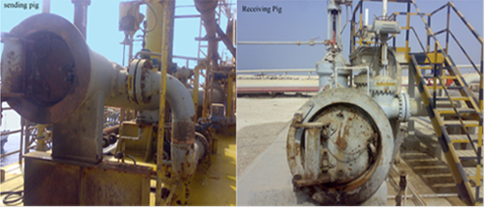

Figure 8: Pig Receiver

1. Oil/oil heat exchangers
2. Pre-flush heat exchanger
3. Gas separator tower
4. Liquid containers of circulating gas compressor
5. set of circulating gas compressors
6. Flush tank
7. Crude oil pumps
8. Heat exchangers of desalination devices
9. Desalination unit
10. Crude oil storage and loading tanks
11. Low pressure gas container
12. set of additional gas compressors
13. Containers for catching sour gas
14. Gas sweetening unit

### Description of the process and operating variables:

Process theory

The operations performed in Salman crude oil stabilization and desalination unit are:

1. stabilizing the vapor pressure of crude oil
2. sweetening
3. Desalination
4. Gas sweetening

In the following, we will briefly examine the mentioned processes:

1. Crude oil vapor pressure stabilization:

In order to prevent the evaporation of crude oil, the safety of its storage in storage tanks and its transportation by tankers, its vapor pressure must be stabilized. This action should be done in such a way that the vapor pressure of the product at the maximum ambient temperature is lower than the atmospheric pressure. For this purpose, it is necessary to separate the light compounds in crude oil, which increase its vapor pressure, in several stages. On the other hand, the separation process should not reduce the API grade of crude oil to an undesired level. In order to optimize the conditions in stabilizing the vapor pressure of crude oil, the temperature of the last stage of separation and the pressure of the third stage of separating gas from oil are considered as operating variables. According to the calculations made to achieve a steam pressure of 13.3 pounds per square inch absolute or 11RVP= and an API degree equal to 35.5 (minimum), the pressure of the separation stage is equal to 30 psia and the temperature of the last stage of separation of gas from oil is equal to 123 degrees Fahrenheit. has been taken

It is necessary to explain that the specifications considered in this part for the process provide the rest of the desired specifications of the single product.

1. Sweetening

Reduction of hydrogen sulfide from the process fluid is called sweetening of said fluid. The act of reducing hydrogen sulphide by stripping in "Salman Crude Oil Stabilization and Desalination" unit is done from crude oil by gas in stripping towers. The gas separated from the oil in the fourth stage of separation, in the gas separator container after condensing, is directed to the stripping towers and performs the stripping process. The reduction of hydrogen sulfide in crude oil (liquid phase) takes place due to the lack of partial pressure of hydrogen sulfide in the gas phase that is injected into the stripping tower. During the contact, some of the possible heavy compounds in the gas separated from the oil in the fourth stage are also absorbed into the crude oil.

The act of stripping crude oil from hydrogen sulfide in stripping towers can also be done by sweet gas.

The exhaust gas from the top of the stripping towers after being condensed together with the exhaust gas from the second stage of separation in order to supply fuel gas for the factory and refinery as well as sweet gas for the stripping towers are directed to the gas sweetening unit.

1. Desalination

Crude oil generally contains sodium and magnesium chlorides, silicon sulfate and iron oxide. Chlorides and sulfates are dissolved in small water droplets and these droplets are placed in a stable emulsion (suspension) in crude oil. These solvents produce hydrochloric acid and sulfuric acid during distillation, and as a result, they create a corrosive environment in the system. In desalination units, 2 to 8% of water is added to the crude oil to completely dissolve the solutes in it. After this stage, the crude oil is subjected to an electrostatic field with a voltage between 15,000 and 35,000 volts. The area of ​​water droplets is connected to each other and collects in the lower part of the salt container. With this operation, it is possible to reduce the amount of solutes with crude oil to 3-4 grams per ton. In order to facilitate the separation, usually before desalination, the viscosity of crude oil is reduced by increasing its temperature.

1. Gas Sweetening

As mentioned in the previous parts, the gas produced in the separator vessels of the second stage and the stripping towers has some acid gases (hydrogen sulfide and carbon dioxide). Regardless of its acidic properties that cause rust in pipes, hydrogen sulfide is a foul-smelling and poisonous gas that causes poisoning even in small amounts. On the other hand, carbon dioxide or carbon dioxide has corrosive properties in the vicinity of water, and its presence in the flow of fuel gas used in factories and refineries reduces the calorific value of gas.

One of the common methods of separating acid gases from the gas flow is using the amine process. Amines have been widely used in the gas sweetening industry due to their alkaline properties and affordable prices. Choosing the right type of amine for the gas sweetening process is done by considering several factors. The most important of these factors is the absorption capacity of acid gases by amine and also the amount of amine that is lost in the process of absorption and reduction. For example, the absorption capacity of acid gases by monoethanolamine is 100 based on the molecular weight ratio of acid gas to amine, while the same capacity is 58 for diethanolamine. On the other hand, the amount of monoethanolamine that cannot be recovered during the gas sweetening process is more than that of diethanolamine.

In Salman Crude Oil Stabilization and Desalination Unit, the type of solution used for gas sweetening is diethanolamine.

The act of absorbing acid gases by diethanolamine or DEA is a chemical reaction that can be summarized in a simple formula, its interaction with acid gases as follows:

* with hydrogen sulfide:
* with Carbon dioxide:

The reactions of the previous slide are all tilted to the right with decreasing temperature and to the left with increasing temperature. In other words, the process of absorbing acid gases by amine solution is an exothermic process, and the process of removing it in the regeneration part is an endothermic process.

One of the problems of the gas sweetening process with diethanolamine is its combination with carbonyl sulfides and carbon disulfide, which causes a small amount of amine to be wasted in the system, so it is necessary to add a certain amount of new amine to the system.

### Overall Description of the Unit

Crude oil sent from Salman, Resalat, Rashadat, and finally Bilal offshore fields are directed to the Salman crude oil stabilization and desalination unit by a 42-inch pipeline. Four operational lines are divided. At the beginning of each operating row, crude oil enters the SECOND STAGE (SEPARATOR) container.

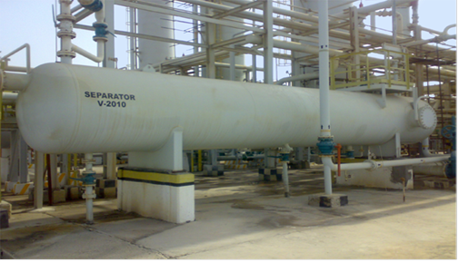

Figure 9: Separator Tank

The oil and gas separated in the separator for sweetening are sent to the separator tower and the gas to the gas sweetening unit in the order of average purification of crude oil (STRIPPER BOOSTER PUMP). In the separator tower, which is actually the third stage of separation, the crude oil enters from the top of the tower. and as a result of contact with the condensed gas of the fourth stage of separation, which enters from the bottom of the tower, or the sweet gas, if necessary, loses most of the sour gases dissolved in it and at the same time absorbs the heavy components of the gas of the fourth stage of separation. Heavy gases by crude oil increase its API degree or in other words make crude oil lighter. Part of the gases coming out of the stripping tower are directed to the gas sweetening unit by the RESIDUE GAS COMPRESSOR. It is sent to the Low-Pressure Flare tower.

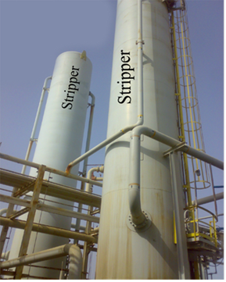

Figure 10: Stripper tower

After this stage, the crude oil is sent to the oil/oil heat exchangers (CRUDE/CRUDE EXCHANGER) for preliminary heating in order to stabilize or control its vapor pressure by crude oil pressure boosting pumps (CRUDE BOOSTE PUMP). The oil exchanges heat with the product of the unit and is heated to a certain extent. The heated crude oil is directed to the PRE-FLASH (HEATER) pre-evaporation converters and in these converters, it is heated up to a temperature of 124 degrees Fahrenheit by steam. The oil phase is under pressure and no evaporation takes place in it.

After the pre-evaporation converters, the oil pressure is reduced to atmospheric level in two consecutive stages. The fourth step is the separation of the gas separation tower (DEGASSING BOOT) whose pressure is 14.8 pounds per square inch absolute. Most of the light oil components in this tower are separated from the oil in the form of gas and are recycled by the circulating gas compressors. GAS COMPRESSOR) are returned to the stripping towers. It is necessary to explain that all the crude oil output from each of the four operating lines is directed to the fourth and fifth stages of separation by a main pipeline.

The gas separator container is actually the protection of the fifth stage of separation against excessive evaporation and the resulting pressure increase. The fifth step is the separation of the evaporation tank (FLASH TANK), whose pressure is equal to atmospheric pressure. The rest of the light components and free water (FREE WATER) along with the oil are separated from the crude oil at this stage. The slope of the tank bottom is towards its center. In order to provide the minimum required suction head pressure for crude oil pumps (CRUDE CHARGE PUMP), the height of crude oil in this tank is kept at least 20 feet (equivalent to 1.6 meters). In this situation, the tank contains 10,215 barrels of crude oil. Therefore, in this situation, when the maximum capacity of the unit is equal to 220,000 barrels of crude oil per day, the minimum residence time of crude oil is about 1 hour and 5 minutes.

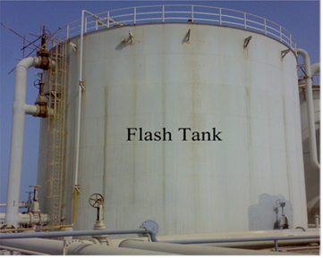

Figure 11: Flash Tank

After the fourth and fifth stages of separation, the crude oil is stabilized and the amount of sour gas with it reaches the optimal level. The stabilized crude oil is then sent to the desalination unit by crude oil pumps (CRUDE CHARGE PUMP). Before the oil enters the desalting vessels (DESALTERS), the temperature of the crude oil in the converters of the desalting unit (DESALTER HEATER) is increased by water vapor to about 130 degrees Fahrenheit. The increase in temperature is to reduce the viscosity of the crude oil and increase the efficiency of the salt vessels. The desalination unit consists of 4 two-stage operating rows. In this unit, salt water along with oil is diluted due to contact with fresh water or sea water and at the same time by electrical coalescing and injection of materials. DEMUL SIFIER is separated from the oil, thus the volumetric percentage of water with the oil and the concentration of dissolved salt in it are reduced to the optimum level.

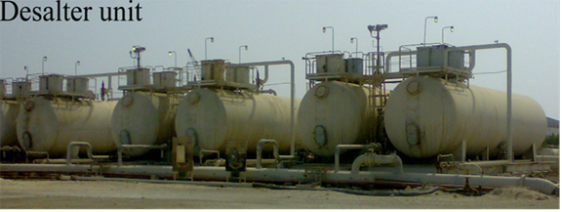

Figure 12: Desalination Unit

The oil output from the desalination units, which is actually the product of the "Salman Crude Oil Stabilization and Desalination" unit, after exchanging heat with the oil output from the stripping towers in the oil exchangers and reducing the temperature, is directed to the atmospheric storage tanks. will be Crude oil stored due to being above the sea level is sent to the wharf for loading without a pump through the measuring unit (METERING).

### Multiple routes of the crude oil

Each of the 42-inch crude oil pipelines are connected to (from) the tanks by the mentioned several ways to two common 42-inch pipelines. They enter the measuring systems (METERING BANK) and then direct the crude oil to the loading area. In some crude oil routes, in addition to the mentioned route, there are facilities for establishing the crude oil route as described below.

1. From crude oil pressure boosting pumps to oil storage tanks
2. From crude oil reprocessing pumps to storage tanks, desalination devices, measuring system and oil refinery.
3. From the crude oil storage tanks to the refinery
4. From the refinery to the storage tanks with oil/oil exchangers for reprocessing, with the position of the valves in these multiple ways, other routes can also be established. There are also two pumps in the multi-way crude oil area, each with a capacity of 3550 gallons per minute for reprocessing crude oil. These pumps receive the crude oil sent from tanks or refineries, which has favorable characteristics, and directs it to the oil/oil heat exchanger pipes.

### Characteristics of crude oil entering the unit from oil fields:

The specifications of the input feed of "Salman Crude Oil Stabilization and Salting Unit" in the design conditions are as follows. According to the above table, most of the feed is supplied from the Salman oil field.

As it is clear in the table, in the design conditions, the unit feed has the highest amount of hydrogen sulfide in its maximum capacity, because the crude oil of the Reshadat does not contain hydrogen sulfide, according to the table, therefore, in the design conditions, feed from this area is considered not taken.

|  |  |
| --- | --- |
| Component | Mole Percent |
|  | 0.0323 |
|  | - |
|  | 0.0998 |
|  | 5.3301 |
|  | 5.1228 |
|  | 7.6593 |
|  | 7.0021 |
|  | 6.2349 |
|  | 6.5793 |
| Mobsharif | 26.2642 |
| Shoyba | 35.4993 |